TEAM ID 179

**TEAM MEMBERS:**

1. **A. SATHWIK: 2303A51178**
2. **Y. MANIKANTA: 2303A51599**
3. **MOSES ANTHONY: 2203A51377**
4. **0.KARTHIK REDDY: 2303A510D9**
5. **B. GNANESHWAR: 2303A51T01**

**JAVA CODE OF THE QUESTION:**

**import java.util.*;**

**class User {**

**String name;**

**int points = 0;**

**int level = 1;**

**List<String> badges = new ArrayList<>();**

**public User(String name) {**

**this.name = name;**

**}**

**public void awardPoints(int pts) {**

**this.points += pts;**

**if (this.points >= 100) {**

**level = 2;**

**if (!badges.contains("Level Up"))**

**badges.add("Level Up");**

**}**

**if (pts >= 50 && !badges.contains("Quiz Master")) {**

**badges.add("Quiz Master");**

**}**

**}**

**public void showProfile() {**

**System.out.println("\n--- User Profile ---");**

**System.out.println("Name: " + name);**

**System.out.println("Points: " + points);**

**System.out.println("Level: " + level);**

**System.out.println("Badges: " + badges + "\n");**

**}**

**}**

**class Quiz {**

**String question;**

**String[] options;**

**int correctIndex;**

**public Quiz(String q, String[] options, int correctIndex) {**

**this.question = q;**

**this.options = options;**

**this.correctIndex = correctIndex;**

**}**

**public boolean ask(Scanner sc) {**

**System.out.println("\n" + question);**

**for (int i = 0; i < options.length; i++) {**

**System.out.println((i + 1) + ") " + options[i]);**

**}**

**System.out.print("Your answer (1-4): ");**

**int choice = sc.nextInt();**

**return (choice - 1) == correctIndex;**

**}**

**}**

**public class Main {**

**static List<User> users = new ArrayList<>();**

**static List<Quiz> quizzes = new ArrayList<>();**

**public static void main(String[] args) {**

**Scanner sc = new Scanner(System.in);**

**quizzes.add(new Quiz("What is doping?", new String[]{**

**"Taking protein", "Illegal substance use", "Training hard", "Hydration"**

**}, 1));**

**quizzes.add(new Quiz("WADA stands for?", new String[]{**

**"World Athletes Drug Association", "World Anti-Doping Agency", "Wrestling Authority", "None"**

**}, 1));**

**quizzes.add(new Quiz("Which of these is prohibited?", new String[]{**

**"Vitamin C", "Creatine", "EPO", "BCAA"**

**}, 2));**

**System.out.print("Enter your name: ");**

**String name = sc.nextLine();**

**User user = new User(name);**

**users.add(user);**

**System.out.println("Welcome to the Anti-Doping Game, " + name + "!");**

**for (Quiz quiz : quizzes) {**

**boolean correct = quiz.ask(sc);**

**if (correct) {**

**System.out.println(" Correct! +50 points");**

**user.awardPoints(50);**

**} else {**

**System.out.println(" Incorrect! No points.");**

**}**

**}**

**user.showProfile();**

**showLeaderboard();**

**sc.close();**

**}**

**static void showLeaderboard() {**

**System.out.println("--- Leaderboard ---");**

**users.sort((u1, u2) -> Integer.compare(u2.points, u1.points));**

**for (User u : users) {**

**System.out.println(u.name + " - " + u. points + " pts");**

**}**

**}**

**}**

**WEBSITE CODE**

**HTML CODE:**

**<!DOCTYPE html>**

**<html lang="en">**

**<head>**

**<meta charset="UTF-8" />**

**<meta name="viewport" content="width=device-width, initial-scale=1.0"/>**

**<title>Clean Sport: Gamified Anti-Doping Platform</title>**

**<link rel="stylesheet" href="style.css"/>**

**</head>**

**<body>**

**<!-- Sound Effects -->**

**<audio id="clickSound" src="https://assets.mixkit.co/sfx/preview/mixkit-click-melodic-tone-1129.mp3"></audio>**

**<audio id="badgeSound" src="https://assets.mixkit.co/sfx/preview/mixkit-achievement-bell-600.mp3"></audio>**

**<!-- Hero Section -->**

**<section class="hero">**

**<h1>Welcome to Clean Sport Quest!</h1>**

**<p>Gamify your way to mastering anti-doping rules</p>**

**<button class="cta-btn" onclick="playClick(); scrollToSection();">Start Your Journey</button>**

**</section>**

**<!-- Platform Features -->**

**<section class="section" id="platform">**

**<h2>Platform Features</h2>**

**<div class="cards">**

**<div class="card">**

**<h3>Points & Badges</h3>**

**<p>Earn rewards as you complete learning modules!</p>**

**<button class="badge-btn" onclick="playBadgeSound()">Unlock Badge</button>**

**</div>**

**<div class="card">**

**<h3>Interactive Quizzes</h3>**

**<p>Test your knowledge and improve instantly.</p>**

**</div>**

**<div class="card">**

**<h3>Progress Tracker</h3>**

**<p>See how far you've come in your clean sport journey.</p>**

**<div class="progress-container">**

**<progress value="45" max="100"></progress>**

**</div>**

**</div>**

**</div>**

**</section>**

**<!-- Leaderboard -->**

**<section class="section leaderboard">**

**<h2>Leaderboard</h2>**

**<ul id="leaderboardList">**

**<li><img src="https://i.pravatar.cc/40?img=1"> <span>Athlete101</span> – 890 pts</li>**

**<li><img src="https://i.pravatar.cc/40?img=2"> <span>FitChamp</span> – 820 pts</li>**

**</ul>**

**<button class="cta-btn" onclick="addScore(); playClick();">Add Random Player</button>**

**</section>**

**<!-- Stats Dashboard -->**

**<section class="section stats">**

**<h2>Your Stats</h2>**

**<p><strong>Modules Completed:</strong> 4 / 10</p>**

**<p><strong>Badges Earned:</strong> 2</p>**

**<p><strong>Total Score:</strong> 1340 pts</p>**

**</section>**

**<!-- Footer -->**

**<footer>**

**<p>© 2025 Clean Sport Gamified by Student Innovators</p>**

**</footer>**

**<script src="main.js"></script>**

**</body>**

**</html>**

**CSS CODE:**

**/* styles.css */**

**body {**

**margin: 0;**

**font-family: 'Poppins', sans-serif;**

**background: #f2f6ff;**

**color: #333;**

**}**

**.hero {**

**background: linear-gradient(135deg, #0052D4, #4364F7, #6FB1FC);**

**color: white;**

**padding: 80px 20px;**

**text-align: center;**

**}**

**.hero h1 {**

**font-size: 2.8rem;**

**margin-bottom: 10px;**

**}**

**.hero p {**

**font-size: 1.2rem;**

**margin-bottom: 20px;**

**}**

**.cta-btn {**

**padding: 12px 25px;**

**background-color: #fff;**

**color: #0052D4;**

**border: none;**

**border-radius: 25px;**

**font-weight: 600;**

**cursor: pointer;**

**transition: transform 0.2s ease;**

**}**

**.cta-btn:hover {**

**transform: scale(1.05);**

**}**

**.section {**

**padding: 50px 20px;**

**text-align: center;**

**}**

**.cards {**

**display: flex;**

**flex-wrap: wrap;**

**justify-content: center;**

**gap: 20px;**

**margin-top: 30px;**

**}**

**.card {**

**background: white;**

**padding: 20px;**

**border-radius: 16px;**

**box-shadow: 0 4px 15px rgba(0,0,0,0.1);**

**width: 280px;**

**}**

**.card h3 {**

**margin-bottom: 10px;**

**font-size: 1.2rem;**

**}**

**.progress-container {**

**max-width: 400px;**

**margin: 0 auto;**

**}**

**progress {**

**width: 100%;**

**height: 20px;**

**border-radius: 10px;**

**overflow: hidden;**

**}**

**.leaderboard ul {**

**list-style: none;**

**padding: 0;**

**max-width: 500px;**

**margin: auto;**

**}**

**.leaderboard li {**

**display: flex;**

**align-items: center;**

**justify-content: space-between;**

**padding: 10px;**

**border-bottom: 1px solid #ccc;**

**}**

**.leaderboard img {**

**border-radius: 50%;**

**margin-right: 10px;**

**}**

**.badge-btn {**

**margin-top: 10px;**

**padding: 8px 20px;**

**background-color: gold;**

**border: none;**

**border-radius: 20px;**

**cursor: pointer;**

**}**

**.stats {**

**max-width: 400px;**

**margin: auto;**

**background: white;**

**padding: 20px;**

**border-radius: 12px;**

**box-shadow: 0 4px 10px rgba(0,0,0,0.1);**

**}**

**footer {**

**background: #0052D4;**

**color: white;**

**text-align: center;**

**padding: 15px 0;**

**}**

**JAVASCRIPT CODE:**

**// script.js**

**function playClick() {**

**const clickSound = document.getElementById('clickSound');**

**clickSound.play();**

**}**

**function playBadgeSound() {**

**const badgeSound = document.getElementById('badgeSound');**

**badgeSound.play();**

**}**

**function scrollToSection() {**

**const section = document.getElementById("platform");**

**section.scrollIntoView({ behavior: 'smooth' });**

**}**

**function addScore() {**

**const leaderboard = document.getElementById("leaderboardList");**

**const newEntry = document.createElement("li");**

**const randomScore = Math.floor(Math.random() * 1000) + 500;**

**newEntry.innerHTML = <img src='https://i.pravatar.cc/40?img=${Math.floor(Math.random()*70)}'> <span>New Player</span> – ${randomScore} pts;**

**leaderboard.appendChild(newEntry);**

**}**

**INTERFACE:**

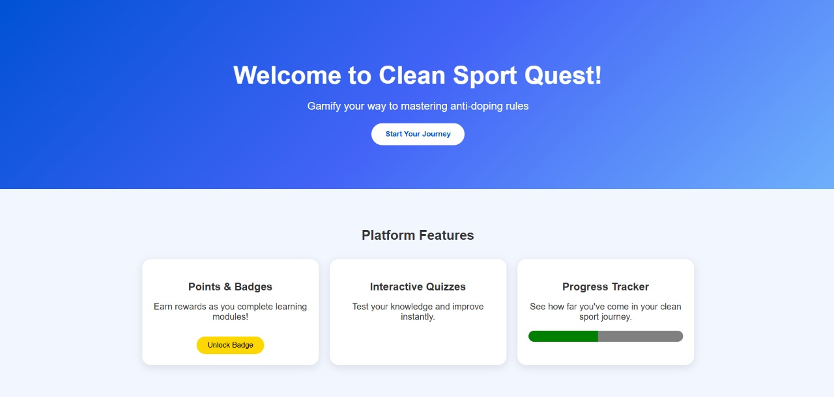

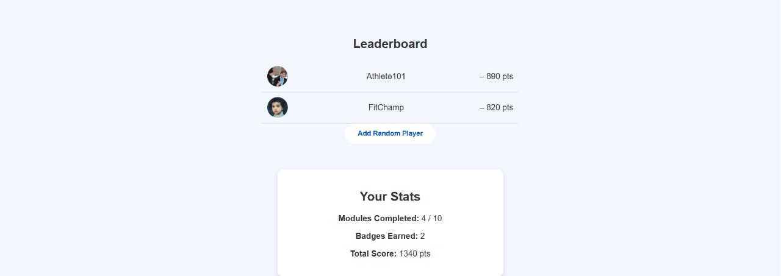

**VIDEO:**